Cambridge Hospital

|  |  |  |
| --- | --- | --- |
| **Supervisor.** | Sir Hasnain Ali | |
| **Batch.** | 2407g2 | |
| **Group.** | A | |
| **Serial No.** | **Enrollment Number** | **Student Name** |
| 1. | Student1594552 | DUA SHAHID |
| 2. | Student1586656 | KIRAN AKBAR |
| 3. | Student1594544 | SYEDA KASHMALA QASIM |
| 4. | Student1594540 | SHUMA REHMAN |
| 5. | Student1597223 | KAHSHAH |
| 6. | Student1597226 | SYEDA ABEER HASAN |

# ACKNOWLEDGEMENT

The first, we would like to express my special thanks of gratitude to my teacher Sir Hasnain Ali, who helped us a lot in finalizing this project within the limited time frame, valuable counselling and assistance for the accomplishment of this project.

Secondly, we would also like to thank the eProject team at Aptech Head Office, who gave us the golden opportunity to do this wonderful project about Cambridge Hospital.

Thirdly, we also thank the eProject team, some of the benefits are as under:

* Re-enforcement of skills happens in the experiential learning process.
* A mentor, ensuring that we do not get drifted, constantly guides us.
* It gives us a lot of confidence to face an interview as we have worked on a project. We can explain virtually everything on the subject we have learnt.

# SYNOPSIS

**Cambridge Hospital Website Redesign**

* **Goal:** Revamp Cambridge Hospital's website for a user-friendly, modern design.
* **Key Features:**
  + Home page with hospital overview and achievements.
  + Sections: About Us, Departments, Facilities, Services, Centers, Contact Us,Reviews, Feedback, Query, Success Stories.
  + Interactive features: Feedback forms, query submission.
  + Department info (e.g., Helpdesk, Doctor Schedule, Billing).
  + Facility details (e.g., Rooms, ICU, Medical Services).
* **Technology Requirements:**
  + Hardware: Minimum Pentium 166, 64MB RAM.
  + Software: HTML editors, VS Code, Dreamweaver, modern web browsers.
* **Outcome:** Practical implementation experience and a professional hospital website.

# PROBLEM DEFINITION

Cambridge Hospital, established in 1928, is a well-known healthcare institution in the town. The hospital organization plans to completely redesign its existing website to meet modern standards and expectations. The goal is to create a user-friendly website with easy navigation, a visually appealing design, and an organized structure. Key requirements include:

1. **Home Page**: Must include a description of the hospital, its founder, and significant achievements. It should also have clear navigation links.
2. **Key Sections:** The website should feature sections like "About Us," "Departments," "Facilities," "Services," "Centers," "Contact Us," "Query," "Feedback," and "Reviews."
3. **Content and Links:** Each section should provide detailed information, be hyperlinked properly, and incorporate images where necessary.
4. **Contact Page:** Should prominently display the address of all hospital locations.
5. **Department Details:** Information on "Helpdesk," "Registration," "Doctor Schedule," "Billing and Accounts," etc.
6. **Facilities:** Includes "Rooms," "ICU," "Medical Facilities," and other hospital amenities.
7. **Services:** Covers general services, health checkups, specialties, and more.
8. **Centers:** Details about centers like diagnostic, cancer, heart, and community health centers.
9. **User Interaction:** Should include options for feedback submission and query input.

The redesigned website should provide a professional yet welcoming appearance, adhere to modern web standards, and utilize appropriate color combinations.

If you would like, I can create additional documents or presentations elaborating on this.

# CUSTOMER REQUIREMENT SPECIFICATION (CRS)

**1. Overview**

The hospital's website needs a complete overhaul to provide a user-friendly interface with intuitive navigation and visually appealing design.

**2. Functional Requirements**

* **Home Page**:
  + Include a description of Cambridge Hospital, including its founder and achievements.
  + Provide navigational links.
* **Information Pages**:
  + Create sections like "About Us," "Department," "Facility," "Services," "Centers," "Contact Us," Reviews," "Query," and "Feedback."
  + Each section must have brief, well-organized content.
* **Hyperlinks and Images**:
  + Properly hyperlink pages.
  + Use images where necessary.
* **Contact Us Page**:
  + Display the address of all hospital locations.
* **Department Details**:
  + Include helpdesk, registration, doctor schedules, billing, and accounts.
* **Facility Information**:
  + Cover details about rooms, ICUs, medical and other facilities.
* **Services**:
  + Include general services, health checkups, specialties, etc.
* **Centers**:
  + Highlight centers like diagnostic, cancer, heart, and community health.
* **Feedback and Query**:
  + Provide a mechanism for users to leave feedback and submit queries.

**3. Non-Functional Requirements**

* Use appropriate color schemes and design elements for a professional and decent appearance.
* Ensure all features are accessible on commonly used web browsers (e.g., Chrome, Firefox, Edge).
* Responsive design for various devices.

**4. Technical Requirements**

* **Hardware**:
  + Minimum: Pentium 166 or better with 64MB RAM.
* **Software**:
  + Development tools: Notepad, HTML editor, VS Code
  + Frameworks: Bootstrap.
  + Design tools: Dreamweaver, Figma.
  + Supported browsers: Chrome, Firefox, MS Edge.

This specification ensures that the redesigned website meets the hospital's operational and user experience goals. If additional details or sections need to be clarified, let me know!

# SCOPE OF THE WORK (IN BRIEF)

* **Objective**: Revamp the existing website of Cambridge Hospital to make it user-friendly, visually appealing, and fully functional.
* **Key Features**:
* Develop a **Home Page** with information about the hospital, including its founder, achievements, and navigation links.
* Include comprehensive sections such as:
  + **About Us**
  + **Departments** (e.g., helpdesk, doctor schedules, billing)
  + **Facilities** (e.g., rooms, ICU, medical equipment)
  + **Services** (e.g., health checkups, specialties)
  + **Centers** (e.g., diagnostic, cancer, heart, community health)
  + **Contact Us** with all hospital locations
  + **Query** and **Feedback** forms
  + **Success Stories**
* Ensure proper hyperlinks, use of images, and brief descriptions for each section.
* Design a visually appealing interface with appropriate color schemes and layouts.
* **Functional Requirements**:
* Provide feedback and query submission functionalities.
* Flash the hospital's address prominently on the "Contact Us" page.
* **Technical Requirements**:
* Use modern tools like Bootstrap for interactivity.
* Employ design tools such as Dreamweaver or Figma for visual development.
* Ensure compatibility with multiple browsers (e.g., Chrome, Firefox, Edge).

# AGGREGATED SITEMAP

Cambridge-Hospital

(0.index.html)

Aura Watches English

(1.Index.html)

# SITEMAP ENGLISH

**Department**

(5.department-details.html)

Silver Tone Watch (Products-W-4.html)

Aura Stardust Watch (Products-W-3.html)

Butterfly Dial Watch (Products-W-2.html)

Aura Glitter Watch (Products-A-1.html)

Aura Rose Tone Watch Set (Products-A-2.html)

Aura White Acrylic Watch (Products-A-3.html)

Aura Embossed Watch

(Products-A-4.html)

**Register Page**

(6.Register.html)

Aura Whit Acrylic Watch

(Products-W-1.html)

Aura Embossed Watch (Products-Q-4.html)

Aura Embossed Watch

(Products-Q-2.html)

Antique Flower Watch (Products-Q-3.html)

Aura White Watch (Products-Q-1.html)

Cambridge Hospital

(1.Index.html)

**Home Page**

(1.Index.html)

**Services Page**

(2.service.html)

About Page

(3.aboutus.html**)**

**Contact Page**

(4.contact.html)

# WIREFRAMES

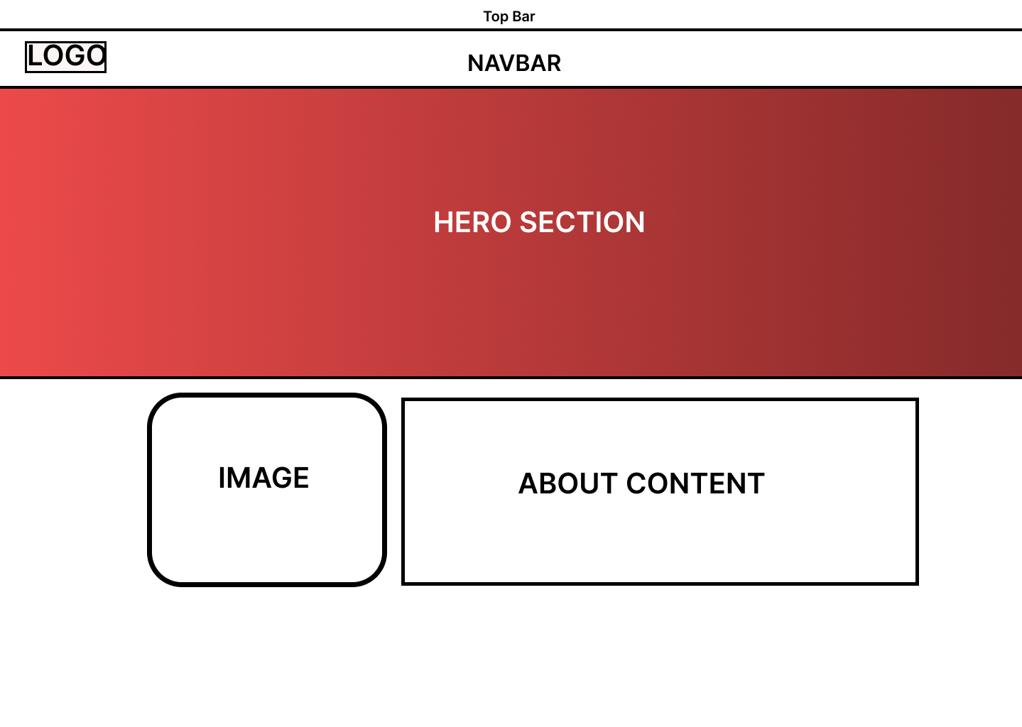

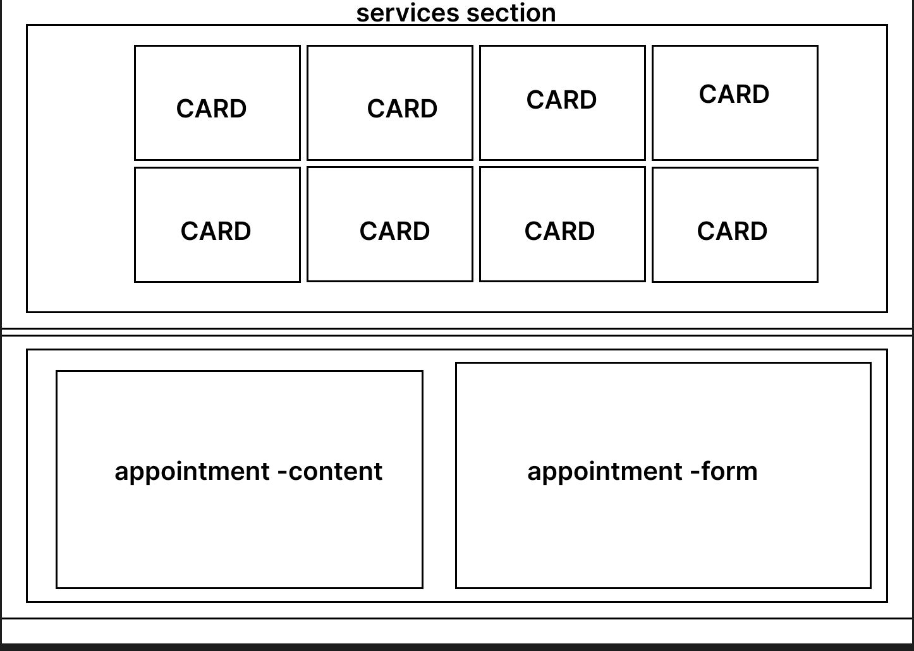

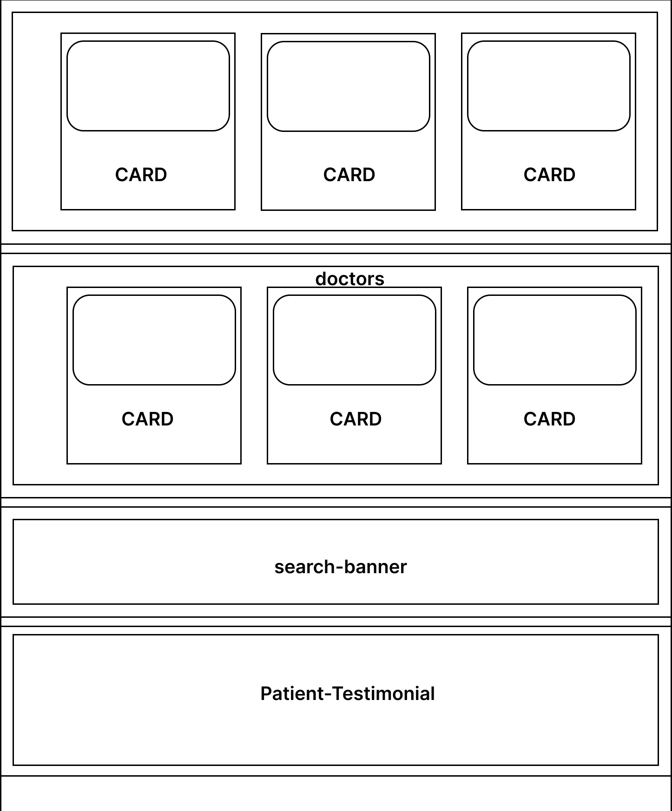

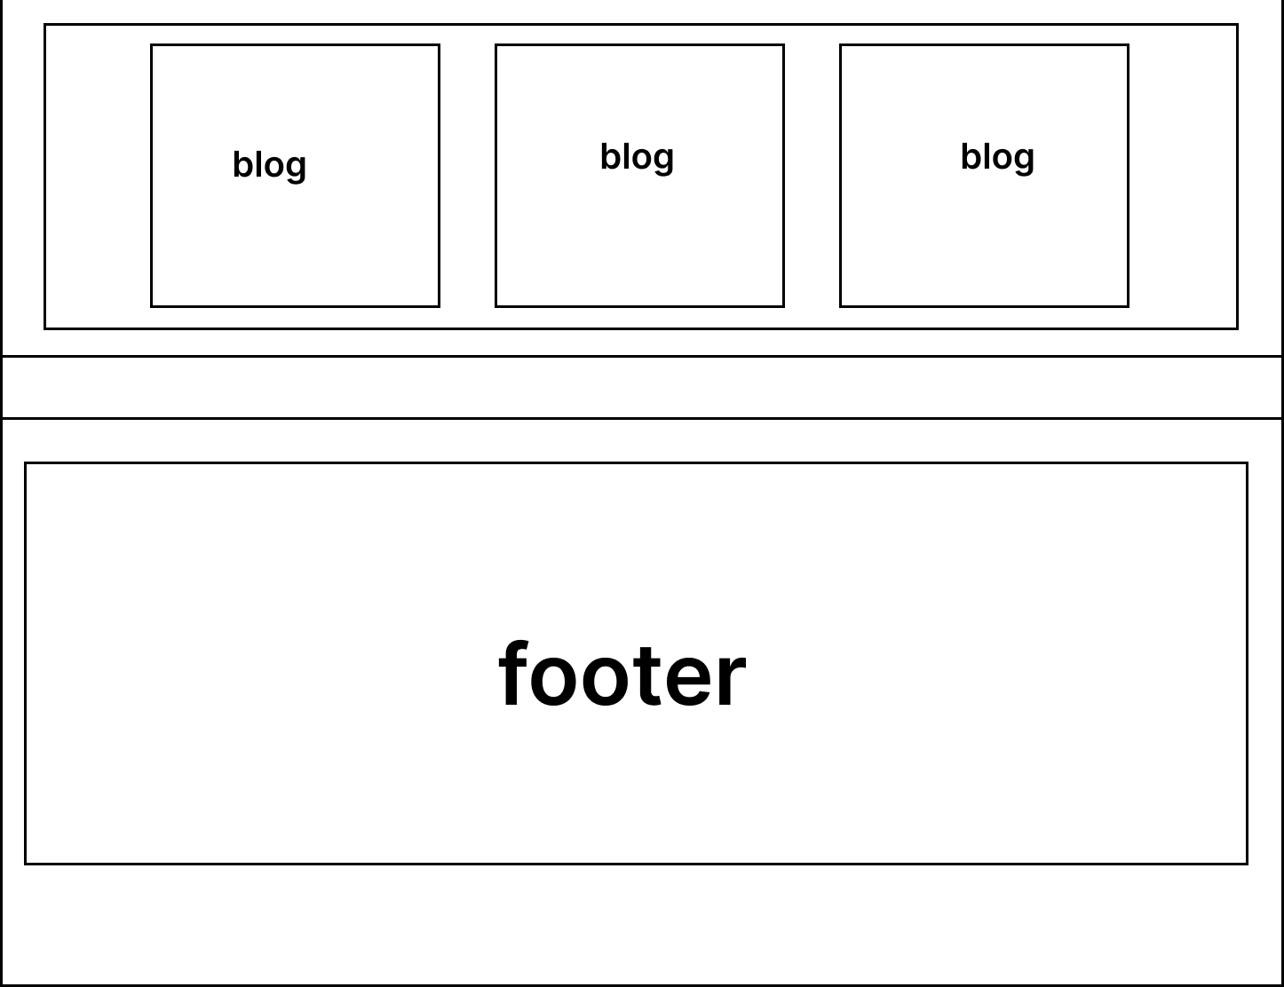

**Thank You!**

# 